C N H | K E Y C L U B

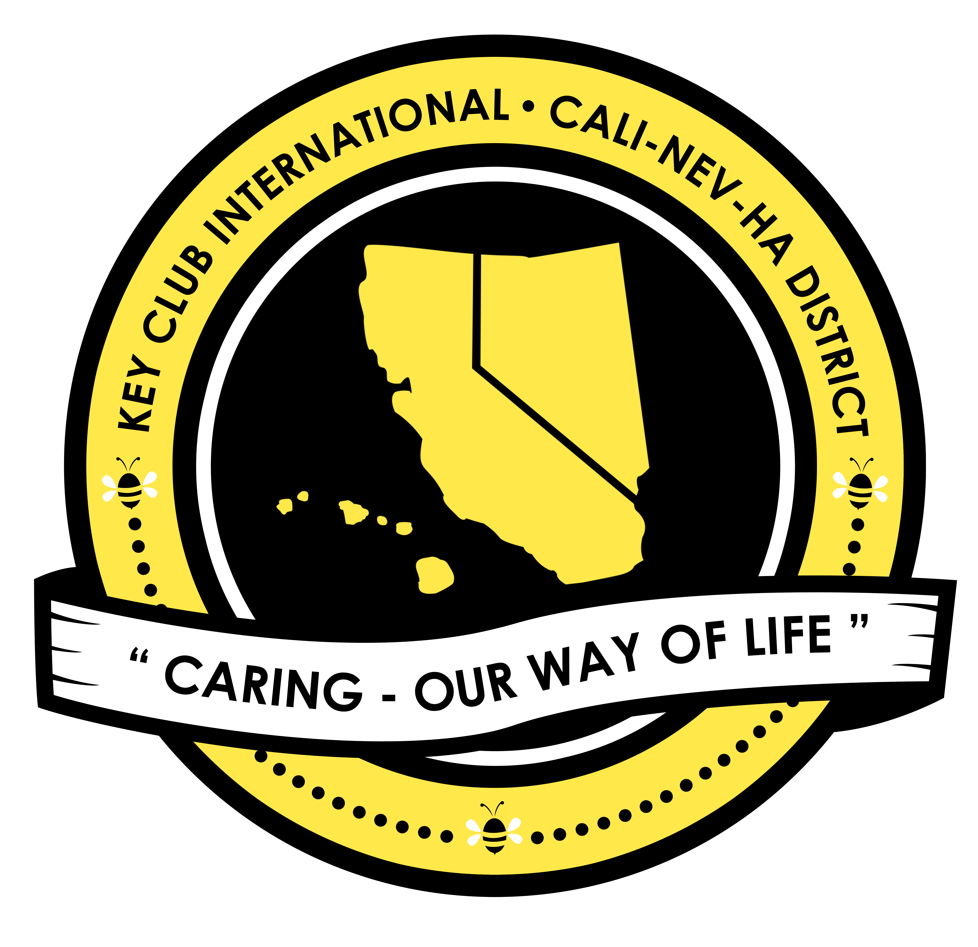
Member Opportunity

District Judging Application

SUBMISSION OVERVIEW
Contest judges review contest submissions and applications at the District level and select qualifying contestants and applicants based on the provided rubrics and criteria.

Read and understand the Judging Application guidelines.
- Complete your application on the next page and save as a PDF.
- E-mail the application to the CNH Contest Archive (cnh.kccontests@gmail.com). Deadlines are different for the two types of District judging applications.

SUBMISSION DEADLINE
District Judging AND On-Site Judging:
Saturday, January 17th, 2021 by 11:59PM PST/HST

E-MAIL SUBMISSIONS TO:
cnh.kccontests@gmail.com
Subject: District Judging Application OR

On-Site Judging Application
Body Text: List attachments
CC: Copy yourself

JUDGING APPLICATION GUIDELINES
RULES GOVERNING THE APPLICANT’S QUALIFICATIONS
- The CNH Key Club District Contests & Awards program is designed to honor individuals who have demonstrated overall excellence throughout the past District Administrative year, but their submissions must be judged properly in order to be awarded. District Judges help the Member Recognition Committee complete this process; it is a privilege to serve as a District Judge. Please do not take these responsibilities lightly. To be eligible for this opportunity, the applicant must pertain to the following:
  - A current Key Club member in good standing who is dues-paid and has served at minimum 50 hours of service.
  - Have a general knowledge about the levels of Key Club as well its focus and mission
  - Have the ability to work with a team and deadlines
- E-SIGNATURES: This application requires electronic signatures (e-signatures) by the applicant, Club President of the applicant, and Faculty or Kiwanis Advisor. E-Signatures for this application are defined as names and contact information provided onto the form. E-Signatures represent the fact that individuals listed have approved the application and supporting documentation. These individuals may be contacted for further verification. Please do not use digital signatures.
- Judging requires time to review applications. Be ready to dedicate or set aside a few hours to judging contest submissions.
- Judges must remain un-biased, level-headed, and focused. They cannot judge any of their home club’s submissions.
- The decisions of the Member Recognition Chair and Division Lieutenant Governors are final.

District Judging
- Judges must review and judge all submissions of the contest category assigned to them. A deadline for the submission of judging score sheets will be provided by the Member Recognition Chair.
- The judging process for District contests occurs via the internet. Judges must be able to download the files sent to them as well as the scoring sheets, complete the sheet, submit the scores, and delete all files.
- Prior to judging official contest submissions, judges will be required to judge a sample portfolio to ensure their understanding of the contest grading rubrics.

On-Site Judging
- Judges must review and judge all submissions of the contest category assigned to them: Club Poster, Traditional Year-In-Review, or Nontraditional Year-In-Review.
- The judging process for On-Site contests occurs in person at District Convention 2021, after the on-site contest submission deadline has passed. Applicants must attend DCON and may not be candidates for District positions, camera or stage interns, or in any other position which may conflict during the times in which these contests are judged.

CNH District Member Recognition Committee
Questions, Comments, Concerns?
Antonio Quesada| Member Recognition Chair | cnhkc.mr@gmail.com

DISTRICT CONTEST JUDGING APPLICATION

APPLICANT INFORMATION
Applicant’s Name: Position:
Key Club: : Club #: Member ID #:
Division: : Region: District: California-Nevada-Hawaii
Contact E-mail: : Contact Phone #: :
Address: City: State:
Postal Code: Country: USA

JUDGING SELECTION
On-Site Judging
If you selected “On-Site Judging” please rank the following, with “1” being your first choice.
Year-in-Review | Poster

Please check one of the following:
District Judging
If you selected “District Judging” please rank the following, with “1” being your first choice and “6” being your last choice.
Club Newsletter
Secretary | Treasurer
President | Vice President
Sandy Nininger

CHECKLIST
INITIALS | ITEMS AND REQUIREMENTS
Club Standards
 | Membership: Paid club membership dues by December 1st
 | Service: Provided a minimum of 50 hours of service
 | Club Status: Home Club is in good standing and has paid dues
Qualifications
 | Has actively attended club events and activities
 | Has actively attended club meetings and Division Council Meetings
 | Has helped with club events and functions
 | Has actively promoted the Key Club core values
Key Club Leadership Positions
List your current and former elected and appointed leadership positions as well as the corresponding terms. Ex. Club Vice President (2020-2021)

SHORT ANSWER
The following must be answered in 1,000 characters (including spaces) or less.
As a Key Club member, how and why does recognition play an important role in this organization?
ADMINISTRATIVE INFORMATION
Date District/International Dues Were Paid (MM/DD/YYYY) | Verification E-Signatures & E-Mails
 | Club President | Club Advisor
CNH District Member Recognition Committee
Questions, Comments, Concerns?
Antonio Quesada| Member Recognition Chair | cnhkc.mr@gmail.com

