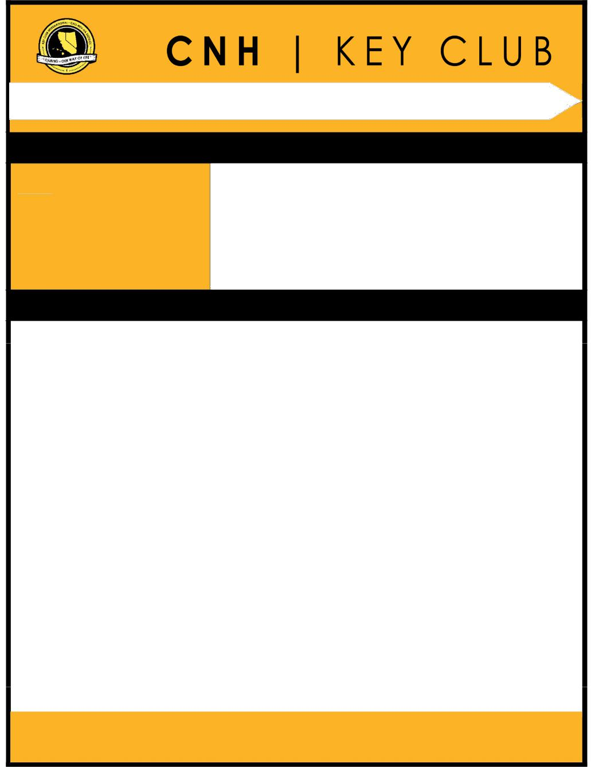

Single Service Contest

SUBMISSION OVERVIEW

SUBMISSION DEADLINE
Saturday, January 25th, 2020 by 11:59PM PST/HST

E-MAIL SUBMISSIONS TO:
cnh.kccontests@gmail.com

Subject: Single Service Contest
Body Text: State your name (First, Last), Region (R##), Division (D##), Club full name and number (H#####)

- Yourself

The Single Service contest is an International contest. Eligible submissions must first be submitted to the CNH Contest Archive for online judging on the District level. At District Convention 2020, Distinguished contest winners will be announced, but only the top submission (one winner) will go on to compete on the International level at ICON 2020.

- Read the Single Service contest guidelines.

- Fill out the “Single Service Contest Entry Form” and provide it at the beginning of the submission.

- E-Mail the submission to the CNH Contest Archive. (cnh.kccontests@gmail.com ). Submissions must be received by Saturday, January 25th, 2020 by 11:59PM PST/HST.

SINGLE SERVICE GUIDELINES

RULES GOVERNING THE KEY CLUB INTERNATIONAL SINGLE SERVICE AWARD
The Single Service award shall provide recognition to Key Clubs for a commendable service project.

- A qualifying single service project shall be defined as a club service project, planned, organized and produced by the Key Club occurring on a single day, consecutive days or recurring on different days. Projects acceptable for this award may include both hands-on service projects and fundraising efforts. In the case of a recurring project, it is the same project that must be repeated for the purpose of achieving the same service goal.

- Entries shall use the official Single Service Entry form and shall have it as the FIRST PAGE of their E-Portfolio.

- Clubs shall compete with other clubs of similar size within four membership categories: Bronze, being 35 members or less; Silver, being 36 to 60 members; Gold, being 61 to 85 members; and Platinum, being 86 members or more.

- Only activities which occurred during the district administrative year shall be included on the report.

- Judging of all entries within each district shall determine one first place winner, and other levels of recognition as deemed appropriate,

- in each membership category. Each first-place report should be forwarded to Key Club International for competition with other first place winners. No changes may be made in the report by the club, district or judging committee. CNH District will submit winning entries to International for judging prior to May 1st. deadline.

- An entry may be disqualified by the judges for reporting incorrect or false information or failure to submit a report according to the rules of the district’s competition. Any disqualification at the district level requires the approval of the district administrator or his/her designee. An entry may be disqualified by the judges at the international level for the same reasons, and any disqualification requires the approval of the International Director.

- Suitable recognition should be provided to clubs achieving first place and other places at district and international levels of competition. At each level of judging, the decisions of the judges are final. No changes, alterations or re-grading will take place after the results have been certified by the judge.
- This application requires electronic signatures (E-Signatures) by the Faculty Advisor, Kiwanis President (local Kiwanis Club), and School Principal. E-Signatures for this application are defined as names and contact information provided into the form. E-Signatures represent the fact that the individuals listed have approved the application and supporting documentation. These individuals may be contacted for further verification. Please do not use digital signatures or scanned photos of signatures.
- DUES-PAID: In order to be eligible to apply for this contest, you must be a dues-paid club by December 1st.

CNH District Member Recognition Committee

Questions, comments, or concerns?
Queenie Lam | Member Recognition Chair | cnhkc.mr@gmail.com

SINGLE SERVICE GUIDELINES

- This application requires electronic signatures (E-Signatures) by the Faculty Advisor, Kiwanis President (local Kiwanis Club), and School Principal. E-Signatures for this application are defined as names and contact information provided into the form. E-Signatures represent the fact that the individuals listed have approved the application and supporting documentation. These individuals may be contacted for further verification. Please do not use digital signatures or scanned photos of signatures.

- The final submission for this contest includes an E-Portfolio. An E-Portfolio for this application is defined as one collective portfolio presenting the best pieces of documentation. This E-Portfolio should be a single PDF that includes all merged information. The E-Portfolio should be in Graphic Standards throughout the entire E-Portfolio. The E-Portfolio should include the following items:

  - Single Service Entry Form
  - Cover Page

      - Name of Club, Division, and Region

      - Name of Service Project

      - Pictures

  - All listed information that is found on Page 1, Letter G which are

    - Service Need

    - Project Plan

    - Project Implementation

    - Final Results

    - Public Awareness

    - Membership Participation

For each section, please be sure to include a Divider.
  - Divider should include the following information:
    - Section Title
    - Information relating to each to sections.
  - End Page

- Application submissions should have a small file size. The following are tips to maintaining this:

  - Include only the best samples of documentation

  - Compress all photos and files before use

  - Compress the final file.

CNH District Member Recognition Committee

Questions, comments, or concerns?
Queenie Lam | Member Recognition Chair | cnhkc.mr@gmail.com

SINGLE SERVICE RUBRIC
CNH District Member Recognition Committee

Questions, comments, or concerns?
Queenie Lam | Member Recognition Chair | cnhkc.mr@gmail.com

This is an international contest and this is the breakdown of the amount of points. There is no limit to the amount of pages. Entries shall be judged based upon an accumulated total of 100 points allocated to the following categories:

- The Need| (10 pts max)
- States the need for this project with details as to why the need exists.
- The Plan| (20 pts max)
- List the steps the project required to successfully be carried out.
- Implementation| (20 pts max)
- Provide a detailed description of the action plans followed to complete this project.
- Final Results | (25 pts max)
- Describe the benefits of the service rendered.
- Discuss how the need was met.

- Public Awareness | (15 pts max)
- Describe how the community played a role in this project and how the overall project was advertised.
- Member Participation | (10 pts max)
- Discuss the number of participating members and how they contributed to this project.

Please remember to use graphic standards and the correct file size

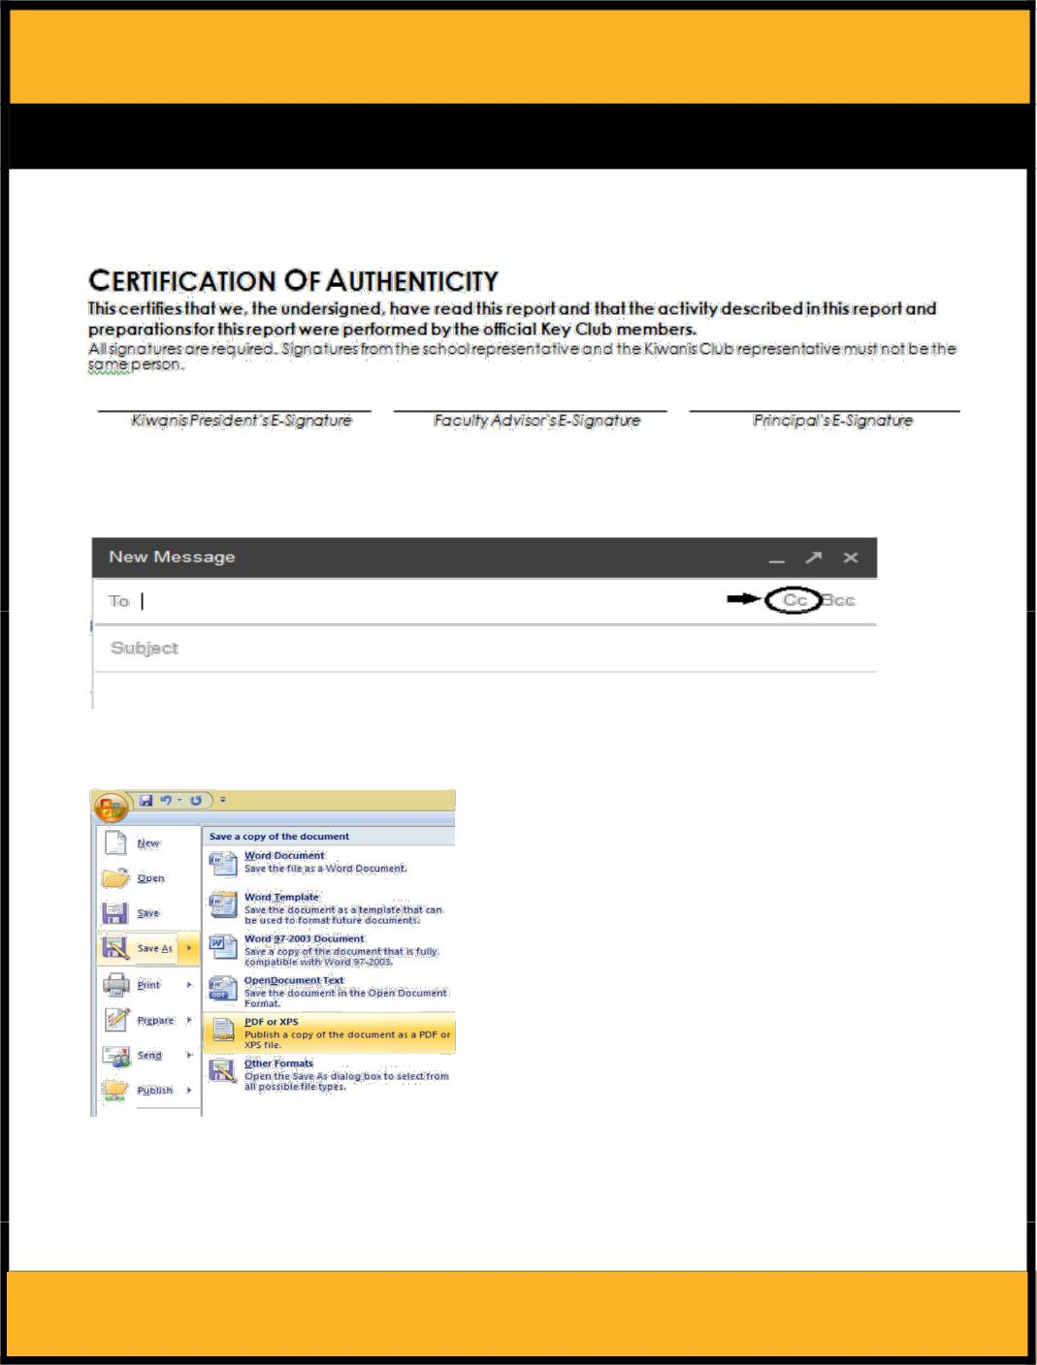
FREQUENTLY ASKED QUESTIONS

1. How do I receive E-Signatures?

Send an email to respective people you would like to receive signatures from, asking permission whether you may include their names as proof of your efforts. After their approval, you may input their names. There is no physical signature. It is the name and contact information of the necessary individuals, typed.

2. What does CC mean?

Send an email to respective people you would like to receive signatures from, asking permission whether you may include their names as proof of your efforts. After their approval, you may input their names. There is no physical signature. It is the name and contact information of the necessary individuals, typed.

3. On what application do I make the E-Portfolio and how do I convert it to a PDF file?

Microsoft Word is a good application to use, and you can also use Publisher and PowerPoint. When saving a file in Microsoft Word 2007, go to save as, and you will see the PDF option:

If your version does not have this function, your E-Portfolio is all complete on a Word DOC. use a PDF file converter online to transform your Word Doc E-Portfolio to a PDF Portfolio. You can use this website to do so: https://www.pdf2go.com

CNH District Member Recognition Committee

Questions, comments, or concerns?
Queenie Lam | Member Recognition Chair | cnhkc.mr@gmail.com

FREQUENTLY ASKED QUESTIONS

4. How do I merge two or more separate PDF files into one?
Use online applications, such as www.pdfmerge.com.

- How do I compress PDFs and photos?

PDF’s: : http://smallpdf.com/ Photos: https://www.pdfcompress.com
(Keep in mind, a “JPEG” photo is already small enough, and would not need any compressions).

- How do I transfer the “Single Service Entry Form” provided on this form to my E-Portfolio?

You can download a PDF converter at www.dopdf.com that allows you to “print” pages into PDF format. With this tool, you can select specific pages in a document, such as the page of the Nomination Form, to individually transfer to PDF format.

7. What if the E-Mail is not received?

When E-Mailing your submission to the recipient be sure to double check for typos and spelling errors to ensure your submission will be on time or be very proactive in your E-Mailing and send it in much earlier from the submission deadline. No late submissions will be judged.

8. What do I do if I want to revise my submission but it has already been sent?

Remember to look over your submission very carefully before E-Mailing it out to the archive. No revisions may be made after it has been submitted. Please remember and take into account, that following the Single Service Contest guidelines, once the decision of the judges and MR Chair has been made final, absolutely NO changes, alterations, or re-judging can be made.

9. Can you clarify what it means to provide the “Single Service Contest Entry Form” at the beginning of the submission?

You will need to place the Single Service Contest Entry Form at the beginning of your E-Portfolio. You will need the PDF version of this to place at the beginning of your submission. Look at FAQ #6 for more help.

10. Is there a specific way I should format the report?

Please be sure that the report follows the Key Club graphic standards. Other than graphic standards, there is no other specific format for the report, but please make sure that it is neat and organized. For even better organization, a table of contents is highly recommended.

You should follow the Key Club graphic standards which can be found at http://www.keyclub.org/fad/cm/gsm.aspx. The entirety of the report should also follow the Key Club graphic standards.

11. Will the CNH District winner of this contest be recognized at DCON?
The winner of this contest will be recognized at District Convention 2020.

12. How do I qualify for the International level contest?

In order to qualify for the International level contest, entries must first be submitted to the CNH Key Club District Member Recognition Chair for judging on the District level. At District Convention 2020, only the first place district winner in each membership category will be eligible to compete in the International contest.

13. Do you have to be present at DCON or ICON for your entry to win this contest?

It is recommended to be present at DCON or ICON; however, you do not need to be present. In the event your submission wins, the award will be given to a representative from your home club/division.

CNH District Member Recognition Committee

Questions, comments, or concerns?
Queenie Lam | Member Recognition Chair | cnhkc.mr@gmail.com

Contest criteria are posted in the Key Club Guidebook on Page 59. Single Service Award 2020

Key Club of: _____________________________________ Club ID #: ___________________ District: _____________

Number of members in club: ______________________Total service hours involved: _______________________

Project name: _____________________________________ Contact name: _________________________________

E-mail: _____________________________________ Phone number with area code: _________________________

Application return address: _____________________________________ City: _____________________________

State/province: _____________________________________ Postal code: _____________ Country: __________

Brief description of project: _________________________________________________________________________

Club membership

- Enter the total number of dues paid club members as of February 1, 2020. 2. Enter the number of paid members in the box below. 3. Use the number in the box to determine the club’s membership category. 4. Place a check next to the category that applies.

Number of dues paid members: |  |  | ______ Bronze (35 members or less) | ______ Silver (36-60 members)
 |  |  | ______ Gold (61-85 members) | ______ Platinum (86 members or more)

A. A qualifying single service project shall be defined as a club service project, planned, organized and produced by the Key Club occurring on a single day or consecutive days, or recurring on different days. In the case of a recurring project, it is the same project that must be repeated for the purpose of achieving the same service goal.

B. Entries shall use the official Single Service Report form cover sheet and shall be submitted to the district for competition according to the guidelines as set by the district. Clubs existing within a non-districted area shall submit their entries to Key Club International.

C. Clubs shall compete with other clubs of similar size within four membership categories: Bronze, being 35 members or less; Silver, being 36 to 60 members; Gold, being 61 to 85 members; and Platinum, being 86 members or more.

D. Entries shall be judged based upon an accumulated total of points allocated to the following categories: service need, 10 points; project plan, 20 points; project implementation, 20 points; final results, 25 points; public awareness, 15 points; member participation, 10 points.

E. Only activities which occurred during the district administrative year shall be included on the report. Clubs existing within a non-districted area shall report activities occurring between May 1 and the following April 30.

F. Judging of all entries within each district shall determine one first place winner, and other levels of recognition as deemed appropriate, in each membership category. Each first place report should be forwarded to Key Club International for competition with other first place winners. No changes may be made in the report by the club, district or judging committee. Reports must be received by the first Friday in May.

G. All entries from non-districted clubs shall be judged to also produce a first place winner in each category. Reports must be received by the first Friday in May.

H. An entry may be disqualified by the judges for reporting incorrect or false information or failure to submit a report according to the rules of the district’s competition. Any disqualification at the district level requires the approval of the district administrator or his/her designee. An entry may be disqualified by the judges at the International level for the same reasons, and any disqualification requires the approval of the International Director.

I. Suitable recognition should be provided to clubs achieving first place and other places at district and International levels of competition. At each level of judging, the decisions of the judges are final. No changes, alterations or re-grading will take place after the results have been certified by the judges.

Certification. This certifies that we, the undersigned, have read this report and that the activity described in this report and preparations for this report were performed by official Key Club members. NOTE: All signatures are required. Signatures from the school representative and the Kiwanis club representative must not be by the same person.

Kiwanis/faculty advisor: __________________________ Principal: _______________________________________________

