

**CNH** | KEY CLUB

CNH Club Website **Contest**

**SUBMISSION** OVERVIEW

Registration **DEADLINE**

**Submit** by September 15, 2019 by 6PM PST/HST.

**SUBMIT** ENTRIES TO:

[**tinyurl.com/1920CNHWEBSITE**](http://tinyurl.com/1819CNHWEBSITE)

## CNH Website Contest Registration Form

## All final changes should be completed by this day.

*The CNH Website contest is a District contest. Eligible applicants must complete the Content Registration Form, as explained in the guidelines. At District Convention 2020 distinguished contest winners will be announced.*

1. Read the CNH Website Contest guidelines.
2. Use the CNH Website Contest Checklist while referencing the CNH Website Contest Guidelines.
3. Registrations must be received September 15, 2019 no later than 6PM PST/HST to the CNH Website Contest Submission form. No late entries will be accepted!

**CLUB WEBSITE CONTEST** GUIDELINES

***The CNH Website shall provide recognition to clubs that have developed exemplary club websites.***

The website contest guidelines are intended to be used in reference to the website contest checklist. The purpose of the guidelines is to provide the members with information for what qualifies each item on the list to deserve the points they are awarded. Words in ***bold italics*** are the important features of each section.

**In order to register your website for this contest, enter the link to the registration google form provided above and answer all questions accurately. Your registration for this contest allows the judges to frequently check your website throughout the process of this term to check for any updates and changes. Checks will be held during the week proceeding registration, last two weeks of October, first two weeks of December, and FINAL judging will be held the last two weeks of January.**

1. **ABOUT PAGE:** The about page should provide a ***brief overview*** of Key Club International, CNH District, your Region, your Division, and your Club. The page should also include any significant achievements that the club has achieved.
2. **UPCOMING SERVICE/FUNDRAISING EVENTS:** The website must include a place where members may access Division and Clubservice events. Details for the event should include date, time, location, and contact information.
3. **PHOTOS/GALLERIES OF PREVIOUS EVENTS:** The website contains visuals from previous Division and Club events.
4. **CONTACT:** The website must include a place where members can find contact information of all the club officers and advisors. The contact page should include ***email, name, position, and a photo*** of each person (optional). There should ***NOT*** be any personal phone numbers on the website.
5. **ARCHIVE OF PAST CLUB MEETING AGENDAS/NEWSLETTERS:** There should be a section where access to past meeting agendas and newsletter are available.
6. **ORGANIZATION/CREATIVITY:** The website should demonstrate each basic element (fonts, colors, and logos) of graphic standards. Please refer back to the CyberKey to review CNH Graphic Standards or click [here](http://www.cnhkeyclub.org/downloads/Resources/Manuals/Manual_CNH_Graphics_Standards.pdf).
7. RESOURCES: Access to member forms, presentations, and other materials that are pertinent to Key Club.
8. MAINTENANCE: Frequently upkeeping your website for each month passes to keep all resources up to date, accurate, and appropriate.
9. **DUES-PAID:** In order to be eligible to apply for this contest, you must be a dues-paid club by December 1st.

***RULES GOVERNING THE CNH KEY CLUB WEBSITE CONTEST***

CNH District **Member Recognition Committee**

Questions, Comments, Concerns?

Queenie Lam| Member Recognition Chair | [cnhkc.mr@gmail.com](mailto:cnhkc.mr@gmail.com)

**CLUB WEBSITE** RUBRIC

1. **Content| (20 pts max)**
2. About Page and Contact Page
3. Club, Division, District, and International Updates
4. Articles and Visuals
5. **Resources| (20 pts max)**
6. Calendar of Upcoming Events
7. Key Club Forms
8. Archive of Past Agendas and Newsletters
9. Provide links to Divsion website, CNH CyberKey, KCI Website
10. **Maintenance| (30 pts max)**

*In order to view the growth and adjustments made to each website, a group of judges will be checking in on the websites three times throughout this term. Website must be updated by the following dates for judging check-ups:*

|  |
| --- |
| ☐ 1st Visit: Week Proceeding Registration **(10 pts max)**  ☐ 2nd Visit: Last Two Weeks of October **(10 pts max)** |
| ☐ 3rd Visit: First Two Weeks in December **(10 pts max)** |
| ☐ 4th Visit (Final Judging): First Two Weeks in February **(SEE CONTENT, RESOURCES, AND CREATIVITY SECTIONS FOR POINT AMOUNT)**   1. **Creativity | (20 pts max)**   Use of backgrounds and pictures/videos to enhance website.  Not similar to other websites/Unique.  No copyright infringement.   1. **Format and Accuracy | (10 pts max)**   Follows Graphic Standards  Follows Proper English Grammar Rules  Adheres to Key Club standards and objects |



1. **Content| (20 pts max)**
2. About Page and Contact Page
3. Club, Division, District, and International Updates
4. Articles and Visuals
5. **Resources| (20 pts max)**
6. Calendar of Upcoming Events
7. Key Club Forms
8. Archive of Past Agendas and Newsletters
9. Provide links to Division website, CNH CyberKey, KCI Website
10. **Maintenance| (30 pts max)**

*In order to view the growth and adjustments made to each website, a group of judges will be checking in on the websites three times throughout this term. Website must be updated by the following dates for judging check-ups:*

|  |
| --- |
| ☐ 1st Visit: Week Proceeding Registration **(10 pts max)**  ☐ 2nd Visit: Last Two Weeks of October **(10 pts max)** |
| ☐ 3rd Visit: First Two Weeks in December **(10 pts max)** |
| ☐ 4th Visit (Final Judging): Last Two Weeks of January **(See Content,**  **Resources, Maintenance, Format and Accuracy Sections for points.)**  **4. Creativity | (20 pts max)**   1. Use of backgrounds and pictures/videos to enhance website. 2. Not similar to other websites/Unique. 3. No copyright infringement.   **5. Format and Accuracy | (10 pts max)**   1. Follows Graphic Standards 2. Follows Proper English Grammar Rules 3. Adheres to Key Club standards and objects |
|  |



CNH District **Member Recognition Committee**

Questions, Comments, Concerns?

Queenie Lam| Member Recognition Chair | [cnhkc.mr@gmail.com](mailto:cnhkc.mr@gmail.com)

**FREQUENTLY ASKED** QUESTIONS

**Where do I submit the website?**

All Club/Division websites should be submitted to the CNH Website Contest Submission Form with the required information for review no later than September 15, 2019 by 6PM PST/HST.

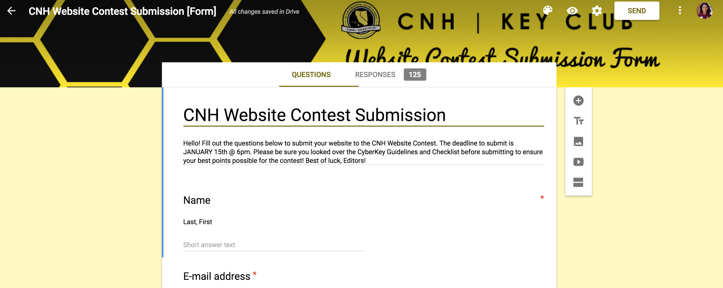

**How can I create a website?**

You can create a website using free website builder such as www.wix.com or www.weebly.com or manually, through HTML coding.

**What are Graphic Standards?**

Graphic Standards help should be maintained throughout the whole entire website. They help unite, brand, and represent CNH Key Club and Key Club International. You can find a manual on Graphic Standards [HERE](http://cnhkeyclub.org/downloads/Resources/Manuals/Manual_CNH_Graphics_Standards.pdf) or on the CNH CyberKey under Graphics.

**Is there a limit or restriction on how creative I can be with the website?**

There is no limit or restriction on creativity in terms of design, however remember to abide by the Graphic Standards rules, SafeKey, and to use appropriate language throughout your website.

**Will the CNH District winners of this contest be recognized at DCON?**

Yes, all division editors who receive Distinguished award willbe recognized at District Convention 2020.

**Do you have to be present at DCON for your entry to win this contest?**

It is recommended to be present at DCON; however, your attendance is not required. In the event that your submission wins, the award will be given to a representative from your home club/division.

**What should I include in the website?**

The Website Criteria is broken up into 4 main parts as follows: Content, Resources, Organization/Creativity, and Maintenance. Please reference the website contest guidelines along with the website contest checklist for a more detailed description.



CNH District **Member Recognition Committee**

Questions, Comments, Concerns?

Queenie Lam| Member Recognition Chair | [cnhkc.mr@gmail.com](mailto:cnhkc.mr@gmail.com)



**CLUB WEBSITE CONTEST** ENTRY FORM

CNH District **Member Recognition Committee**

Questions, Comments, Concerns?

Queenie Lam| Member Recognition Chair | [cnhkc.mr@gmail.com](mailto:cnhkc.mr@gmail.com)

## PLEASE TYPE OR PRINT THE INFORMATION ON THIS FORM, SAVE IT AS A PDF FILE, AND ATTACH IT TO YOUR ELECTRONIC SUBMISSION ALONG WITH CONTENT SUBMISSION FORM.

Distinguished entries will be recognized at District Convention. Please note that the Entry Form must be submitted to [cnh.kccontests@gmail.com](mailto:cnh.kccontests@gmail.com) no later than September 15, 2019 at 6PM PST/HST, along with the Contest Registration Form no later than September 15, 2019 at 6PM PST/HST. Appropriate recognition will be provided to the Key Club

**CLUB INFORMATION**

Key Club: ___________ District: **California-Nevada-Hawaii**  Division: ____ Region: ____ Club #: ___________

# EDITOR INFORMATION

Contact Name: Contact E-mail: Contact Phone #: ________

# WEBSITE LINK

_______________________________________________________________________________________

# CERTIFICATION OF ORIGINALITY

**This certifies that we, the undersigned, verify that the website submitted to this contest is authentic, original products that adhere to copyright laws, and were distributed to the club membership.**

There **must** be 3 people to certify originality: the Editor of the website being submitted to this contest; the Club President; and one advisor. An

Individual may only certify originality once.

|  |  |  |  |
| --- | --- | --- | --- |
| **POSITION** | **E-SIGNATURE** | **E-MAIL** | **PHONE W/ AREA CODE** |
| Editor |  |  |  |
| Club President |  |  |  |
| Advisor |  |  |  |

**EXPLANATION OF DISTRIBUTION**

How is the website distributed to the membership, with the sponsoring Kiwanis club, and with the school administration? How frequently was the website distributed? The form will expand as needed.

|  |  |  |
| --- | --- | --- |
| **Explanation of Distribution Frequency** | | |
| **Membership** |  |  |
| **Sponsoring Kiwanis Club** |  |  |
| **School Administration** |  |  |